**What is the Development Package?**

An ABAP package is a transportable ABAP repository object that groups development objects of an ABAP system.

**How to Create a Development Package?**

**Please follow the steps below to create a development package:**

Enter t-code **SE80** in the SAP command field and **Execute** it.

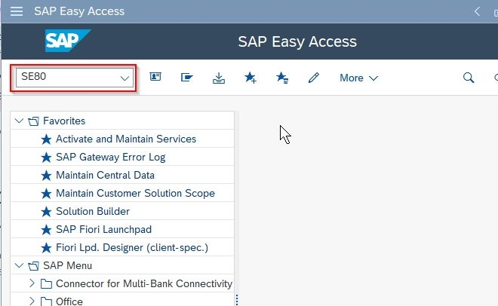

Next under the **Repository Browser** tab choose the **Package** for the context menu

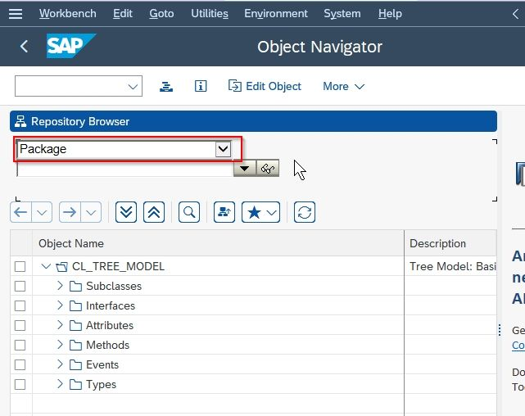

Now enter the package name i.e. **ZDEMOPACKAGE** and press **Enter** key to proceed further

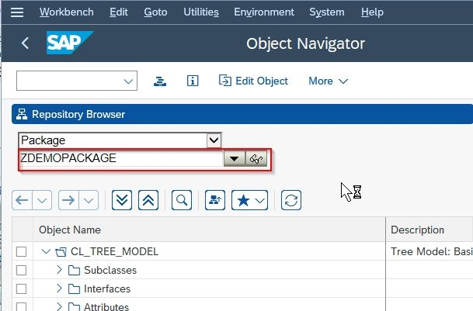

On the next popup window click the **Yes** button to confirm that you want to create a new package

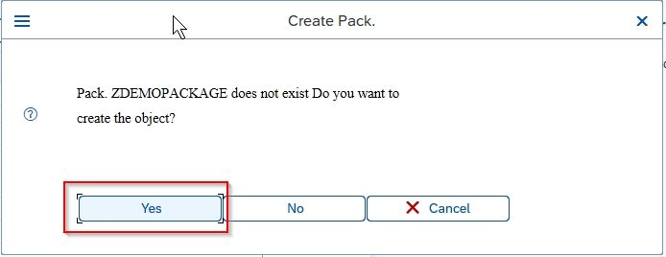

Now add a **Short description** of the package i.e. **Demo Package** and click the **Confirm** button

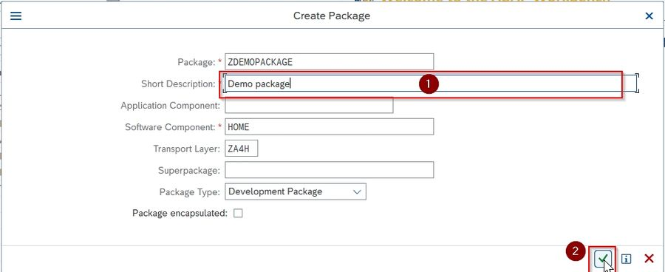

Now the user needs to add the package in a **Transport Request**. Click the **Create** button If you don’t have any transport request

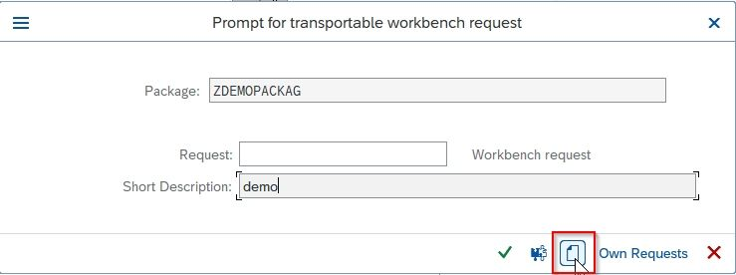

Now on the next screen choose a suitable **Short Description**

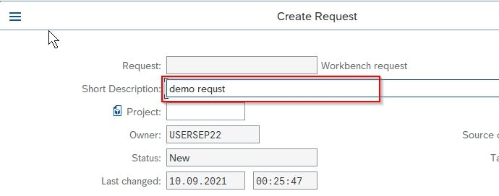

Next click on the **Save** button to save the new **Transport Request**

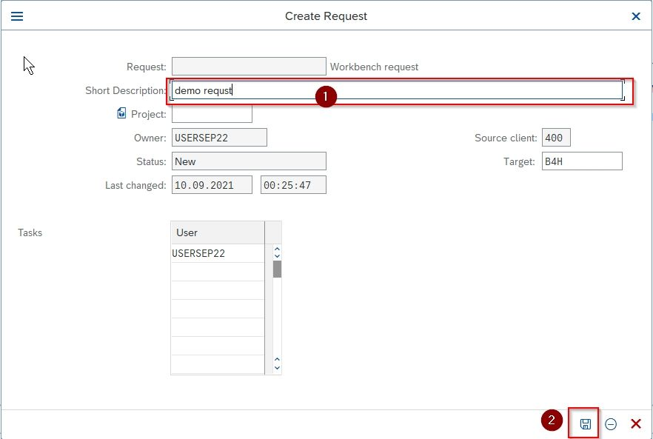

Now once a new **Transport Request** is created you can confirm the selection of **transport request**and clickon the **Continue** button to completer the process.

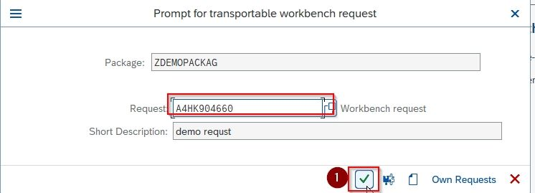

A new **Development Package** is created. User can use the created package to organize your development object.

